Department of Science and Humanities

F Y B Tech SEM II 2021-22
Engineering Physics Lab Course

Photoelectric Effect
Name: Pargat Singh
Roll No: 16010121045
Date: 13 April 2022
Batch: A2

Aim: To understand the phenomenon of Photoelectric effect as a whole.

To plot a graph connecting photocurrent and applied
potential for (i) varying intensity; (ii) varying
wavelength/frequency.

To draw stopping potential as a function of frequency
of incident radiation to determine the Planck's constant
(home assignment)

Apparatus: Ammeter, Voltmeter, Light meter, Photodiode, Phototransistor

Observation Table:

Material: Copper
Area of plates: 0.5 cm²

TABLE I: Fixed wavelength, varying intensity:
Wavelength: 150 nm
Intensity = 15 W/m² |  | Intensity = 20 W/m² |  | Intensity = 25 W/m²
Voltage (V) | Current (µA) | Voltage (V) | Current (µA) | Voltage (V) | Current (µA)
0 | 26.83 | 0 | 35.77 | 0 | 44.71
-0.4 | 23.83 | -0.4 | 31.77 | -0.4 | 39.71
-0.8 | 20.83 | -0.8 | 27.77 | -0.8 | 34.71
-1.2 | 17.83 | -1.2 | 23.77 | -1.2 | 29.71
-1.6 | 14.83 | -1.6 | 19.77 | -1.6 | 24.71
-2.0 | 11.83 | -2.0 | 15.77 | -2.0 | 19.71
-2.4 | 8.83 | -2.4 | 11.77 | -2.4 | 14.71
-2.8 | 5.83 | -2.8 | 7.77 | -2.8 | 9.71
-3.2 | 2.83 | -3.2 | 3.77 | -3.2 | 4.71
-3.6 | 0 | -3.6 | 0 | -3.6 | 0
V_{S} =-3.6 | 0 | V_{S} =-3.6 | 0 | V_{S} =-3.6 | 0
V_{S}: Stopping potential
TABLE II: Fixed intensity, varying wavelength:
Intensity: 30 W/m²
Wavelength = 100 nm |  | Wavelength = 150 nm |  | Wavelength = 200 nm
Voltage (V) | Current (µA) | Voltage (V) | Current (µA) | Voltage (V) | Current (µA)
0 | 115.74 | 0 | 53.66 | 0 | 22.62
-0.9 | 102.24 | -0.4 | 47.66 | -0.2 | 19.62
-1.8 | 88.74 | -0.8 | 41.66 | -0.4 | 16.62
-2.7 | 75.24 | -1.2 | 35.66 | -0.6 | 13.62
-3.6 | 61.74 | -1.6 | 29.66 | -0.8 | 10.62
-4.5 | 48.24 | -2.0 | 23.66 | -1.0 | 7.62
-5.4 | 34.74 | -2.4 | 17.66 | -1.2 | 4.62
-6.3 | 21.24 | -2.8 | 11.66 | -1.4 | 1.62
-7.2 | 7.74 | -3.2 | 5.66 | -1.6 | 0
V_{S} =-7.8 | 0 | V_{S} =-3.6 | 0 | V_{S} =-1.6 | 0

Graphs:
- Voltage (X-axis) v/s current (Y-axis) for different intensities.
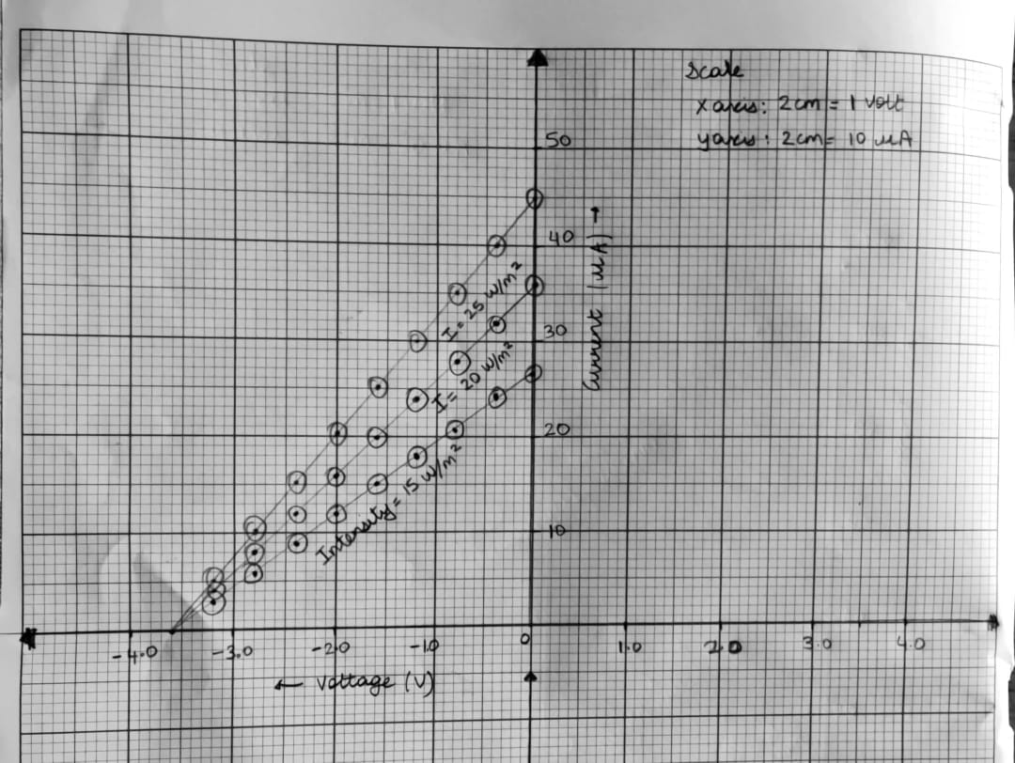

- Voltage (X-axis) v/s current (Y-axis) for different wavelengths.
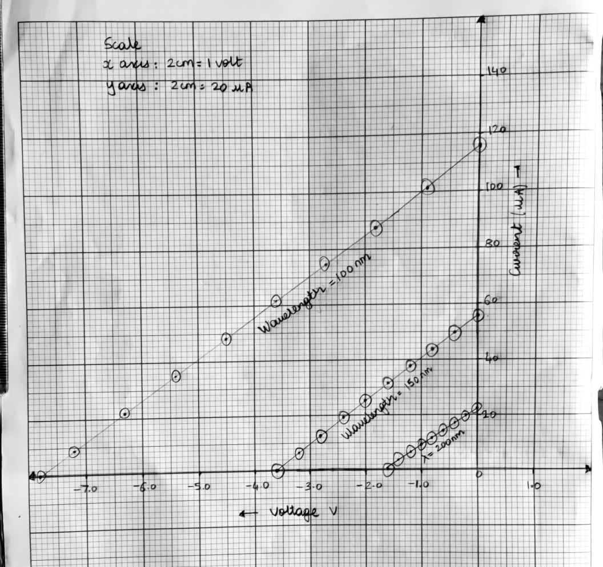
Home Assignment:
Plot graph of KE v/s frequency. From this graph, determine the following: cut-off wavelength, work function of the material of photocell and Planck’s constant.

- λ =100nm x 1m/1 x 10⁹nm = 1 x 10⁻⁷ m
c = f λ
⸫ f = c/ λ
So, f = 3 x 10⁸ m/s = 3 x 10¹⁵ Hz
1 x 10⁻⁷ m

- λ =150nm x 1m/1 x 10⁹nm = 1.5 x 10⁻⁷ m
c = f λ
⸫ f = c/ λ
So, f = 3 x 10⁸ m/s = 2 x 10¹⁵ Hz
1.5 x 10⁻⁷ m

- λ =200nm x 1m/1 x 10⁹nm = 2 x 10⁻⁷ m
c = f λ
⸫ f = c/ λ
So, f = 3 x 10⁸ m/s = 1.5 x 10¹⁵ Hz
2 x 10⁻⁷ m

λ (nm) | 100 | 150 | 200
F(10¹³ Hz) | 3 x 10¹⁵ Hz | 2 x 10¹⁵ Hz | 1.5 x 10¹⁵ Hz
U(V) | 7.8 | 3.6 | 1.6
E_{k} (ev) | 7.8 | 3.6 | 1.6

We know that, h = Δ E_{k} / Δf = Δy/ Δx (slope)

h = (7.8 ev – 1.6 ev) x 1.6 x 10⁻¹⁹ J
1Ev
3 x 10¹⁵ Hz – 1.50 x 10¹⁵ Hz

h ~ 6.61 x 10⁻³⁴ Js Work Function=-4.1 ev Cut-off frequency= 2.73 x 10⁻⁷
